A
Industrial Oriented Mini Project Report On

A DEEP LEARNING-BASED APPROACH FOR INAPPROPRIATE CONTENT DETECTION AND CLASSIFICATION OF YOUTUBE VIDEOS
(Submitted in partial fulfillment of the requirements for the award of Degree)

BACHELOR OF TECHNOLOGY
In

COMPUTER SCIENCE AND ENGINEERING (DATA SCIENCE)

By
N.JYOTSNA(237R1A67H2) B.AJITH KUMAR(227R1A67E1)
P.POOJA YADAV(237R1A67H6) M.AKSHITH(237R1A67G7)

Under the Guidance of

Dr. A.MAHENDAR
Associate Professor & HOD-CSE(DS)


DEPARTMENT OF COMPUTER SCIENCE AND ENGINEERING (DATA SCIENCE)
CMR TECHNICAL CAMPUS
UGC AUTONOMOUS
(Accredited by NAAC, NBA, Permanently Affiliated to JNTUH, Approved by AICTE, New Delhi) Recognized Under Section 2(f) & 12(B) of the UGCAct.1956, Kandlakoya (V), Medchal Road, Hyderabad-501401.
April, 2026.

DEPARTMENT OF COMPUTER SCIENCE AND ENGINEERING (DATA SCIENCE)



CERTIFICATE

This is to certify that the Industrial Oriented Mini Project Report entitled “Monkey pox Detection using Modified VGG16 & Custom CNN Model” being submitted by N.JYOTSNA(237R1A67H2), P.POOJA YADAV(237R1A67H6),B.AJITH KUMAR(227R1A67E1),M.AKSHITH(237R1A67G7)in partial fulfillment of the requirements for the award of the degree of B.Tech in Computer Science and Engineering to the Jawaharlal Nehru Technological University Hyderabad, during the year 2025-2026.
The results embodied in this thesis have not been submitted to any other University or Institute for the award of any degree or diploma.

Dr. A.MAHENDAR Dr. K. Murali
Associate Professor HOD-CSE(DS)
INTERNAL GUIDE

Dr. A. Raji Reddy External Examiner
Director

Submitted for viva-voce Examination held on

ACKNOWLEDGEMENT

We take this opportunity to express our gratitude to the people who have been instrumental in the successful completion of this project, we take this opportunity to express our profound gratitude and deep regard to our guide A.mahendar, Designation for his exemplary guidance, monitoring and constant encouragement throughout the project work. The blessing, help and guidance given by him/her shall carry us a long way in the journey of life on which we are about to embark.
We also take this opportunity to express a deep sense of gratitude to the Project Review Committee (PRC) coordinators N. Soujanya, Shafana Bakshi, Bhookya Ramesh, S. Raghavendra, V. Rajesh, J. Shiva, B. Sangamitra, P. Ashwini for their cordial support, valuable information and guidance, which helped us in completing this task through various stages.
We are also thankful to Dr. K. Murali, Head, Department of Computer Science and Engineering (Data Science) for providing encouragement and support for completing this project successfully.
We are deeply grateful to Dr. A. Raji Reddy, Director, for his cooperation throughout the course of this project. Additionally, we extend our profound gratitude to Sri. Ch. Gopal Reddy, Chairman, Smt. C. Vasantha Latha, Secretary and Sri. C. Abhinav Reddy, Vice-Chairman, for fostering an excellent infrastructure and a conducive learning environment that greatly contributed to our progress.
The guidance and support received from all the members of CMR Technical Campus who contributed to the completion of the project. We are grateful for their constant support and help.
Finally, we would like to take this opportunity to thank our family for their constant encouragement, without which this assignment would not be completed. We sincerely acknowledge and thank all those who gave support directly and indirectly in the completion of this project.

N.JYOTSNA(237R1A67H2) B.AJITH(227R1A67E1)
P.POOJA YADAV(237R1A67H6) M.AKSHITH(237R1A67G7)

ABSTRACT

Monkeypox is an emerging viral disease that has gained global attention due to its rapid spread and similarity to other skin-related infections. Early detection is essential to prevent transmission and ensure timely treatment. However, traditional diagnostic methods rely on laboratory testing and expert analysis, which can be time-consuming and may delay diagnosis.
In this project, an Artificial Intelligence-based approach is proposed for the early detection of Monkeypox using deep learning techniques. Two models, Modified VGG16 (transfer learning) and a Custom Convolutional Neural Network (CNN), are utilized to analyze skin images and classify them as infected or normal. The dataset is preprocessed through image resizing, normalization, and splitting into training and testing sets.
The performance of the models is evaluated using standard metrics such as Accuracy, Precision, Recall, and F1-score. Experimental results indicate that the Custom CNN achieves higher accuracy compared to VGG16, making it more effective for detection. The proposed system provides a fast, reliable, and scalable solution to assist healthcare professionals in early screening and control of Monkeypox spread.

TABLE OF CONTENTS
ABSTRACT |  |  |  | i
LIST OF FIGURES |  |  |  | iii
LIST OF TABLES |  |  |  | v
1. | INTRODUCTION |  |  | 1
 | 1.1 | PROJECT PURPOSE |  | 2
 | 1.2 | PROJECT FEATURES |  | 3
2. | LITERATURE SURVEY |  |  | 4
 | 2.1 | REVIEW OF RELATED WORK |  | 6
 | 2.2 | DEFINITION OF PROBLEM STATEMENT |  | 8
 | 2.3 | EXISTING SYSTEM |  | 8
 | 2.4 | PROPOSED SYSTEM |  | 10
 | 2.5 | OBJECTIVES |  | 11
 | 2.6 | HARDWARE & SOFTWARE REQUIREMENTS |  | 12
 |  | 2.6.1 | HARDWARE REQUIREMENTS | 12
 |  | 2.6.2 | SOFTWARE REQUIREMENTS | 12
3. | SYSTEM ARCHITECTURE & DESIGN |  |  | 13
 | 3.1 | PROJECT ARCHITECTURE |  | 14
 | 3.2 | DESCRIPTION |  | 15
 | 3.3 | DATA FLOW DIAGRAM |  | 16
4. | IMPLEMENTATION |  |  | 18
 | 4.1 | ALGORITHMS USED |  | 19
 | 4.2 | SAMPLE CODE |  | 26
5. | RESULTS & DISCUSSION |  |  | 37
6. | VALIDATION |  |  | 47
 | 6.1 | INTRODUCTION |  | 48
 | 6.2 | TEST CASES |  | 49
 |  | 6.2.1 | UPLOADING DATASET | 48
 |  | 6.2.2 | CLASSIFICATION | 48
7. | CONCLUSION & FUTURE ASPECTS |  |  | 50
 | 7.1 | PROJECT CONCLUSION |  | 51
 | 7.2 | FUTURE ASPECTS |  | 52
8. | BIBLIOGRAPHY |  |  | 53
 | 8.1 | REFERENCES |  | 54
 | 8.2 | GITHUB LINK |  | 55

LIST OF FIGURES

FIGURE NO | FIGURE NAME | PAGE NO
Figure 3.1 | Workflow of Monkeypox Detection System Using VGG16 and Custom CNN Model. | 14
Figure 3.2 | Data Flow Diagram of Deep Learning-Based Monkeypox Detection System. | 17
Figure 4.1 | In above screen we have two folders and just go inside any folder to view those images | 23
Figure 4.2 | Screenshot of the "Inappropriate Content" Folder Showing Sample Image Files | 24
Figure 5.1 | GUI/Main Interface of Monkeypox Detection using Modified VGG16 & Custom CNN Model | 37
Figure 5.2 | Loaded : Loaded sample image of A Deep Learning-Based Approach for monkeypox detection | 38
Figure 5.3 | GUI Showing Dataset Loaded in Monkeypox Detection System | 39
Figure 5.4 | Monkeypox Dataset Image Samples | 40
Figure 5.5 | System Interface for Monkeypox Detection | 41
Figure 5.6 | Confusion Matrix of Custom CNN Model | 42
Figure 5.7 | Performance Comparison of Modified VGG16 and Custom CNN Models | 43

Figure 5.8 | GUI for Monkeypox Detection System – Image Selection Interface | 44
Figure 5.9 | Classification Result – Monkeypox Detected | 45
Figure 5.10 | Classification Result – Normal Skin Detected | 46

LIST OF TABLES

TABLE NO | TABLE NAME | PAGE NO
Table 6.2 | Test caces | 49

1.INTRODUCTION

INTRODUCTION

Monkeypox is a viral infectious disease that has gained global attention due to its increasing spread in recent years. It is transmitted through close contact with infected individuals, animals, or contaminated materials, and commonly presents symptoms such as fever, skin rashes, and lesions. These symptoms often resemble other skin diseases, making early and accurate diagnosis challenging. Traditional diagnostic methods rely on laboratory testing and clinical examination, which can be time-consuming and require skilled medical professionals.
With advancements in Artificial Intelligence and deep learning, automated systems can assist in faster and more accurate disease detection. In this project, a Monkeypox detection system is developed using Modified VGG16 (Transfer Learning) and a Custom CNN model. These models are trained on skin image datasets to classify images as infected or normal. The proposed system aims to provide a quick, reliable, and efficient solution for early detection, helping healthcare professionals in timely diagnosis and reducing the spread of the disease.

PROJECT PURPOSE
The main purpose of this project is to design and develop an efficient and automated system for the early detection of Monkeypox using advanced deep learning techniques. Early identification of the disease is very important to prevent its rapid transmission and to provide timely medical care. Traditional diagnostic methods, such as laboratory testing and manual examination, are often time-consuming, require skilled professionals, and may delay the diagnosis process, especially during outbreaks.
In this project, Modified VGG16 (Transfer Learning) and a Custom Convolutional Neural Network (CNN) are implemented to analyze skin images and accurately classify them as Monkeypox or normal. The system includes data preprocessing steps such as image resizing, normalization, and dataset splitting to improve model performance. By leveraging these models, the system aims to achieve high accuracy, faster prediction, and reliable results.
The proposed solution reduces human effort, speeds up the detection process, and supports healthcare professionals in large-scale screening. Overall, the project aims to provide a fast, accurate, and scalable tool that can assist in early diagnosis, improve healthcare efficiency, and help in controlling the spread of Monkeypox.

PROJECT FEATURES
This project incorporates several key features to improve the accuracy and efficiency of Monkeypox detection from skin images:
Automated Disease Detection:The system uses deep learning models such as Modified VGG16 (Transfer Learning) and a Custom CNN to automatically analyze skin images and detect Monkeypox. These models extract important features from images and identify patterns related to the disease, ensuring high detection accuracy.
Binary Classification:The model performs classification of images into two categories: Monkeypox-infected and Normal skin. This helps in quick and clear identification of the disease, making the system simple and effective for practical use.
Image Preprocessing Techniques:The system applies preprocessing steps such as image resizing, normalization, and dataset splitting. These steps improve the quality of input data and enhance the performance and accuracy of the models.
High Accuracy and Performance Evaluation:The models are evaluated using metrics such as Accuracy, Precision, Recall, and F1-score. The results show that the Custom CNN achieves up to 99% accuracy, ensuring reliable predictions.
Fast and Scalable System:The proposed system is designed to provide quick predictions and can handle large datasets efficiently. It can be used for real-time screening and large-scale healthcare applications.
By integrating these features, the proposed system provides a fast, accurate, and automated solution for Monkeypox detection, assisting healthcare professionals in early diagnosis and helping to control the spread of the disease.

2. LITERATURE REVIEW

LITERATURE REVIEW

With the increasing spread of Monkeypox and its resemblance to other skin-related diseases, early and accurate detection has become a critical challenge in the healthcare domain. Traditional diagnostic methods rely on laboratory testing and clinical expertise, which are often time-consuming and may delay treatment. This has led to the adoption of machine learning and deep learning techniques for automated disease detection using medical images. This literature survey reviews existing approaches for skin disease and Monkeypox detection, highlighting their methodologies, strengths, and limitations.
Early research in disease detection primarily focused on traditional machine learning techniques such as Support Vector Machines (SVM), Decision Trees, and Random Forest. These methods relied on manually extracted features like color, texture, and shape of skin lesions. For instance, studies proposed SVM-based classifiers using handcrafted features, which achieved moderate accuracy but struggled with complex image variations. Later, Random Forest models improved classification performance by reducing false predictions, but they lacked the ability to capture deeper patterns in image data.
With advancements in deep learning, Convolutional Neural Networks (CNNs) became widely used for medical image analysis due to their ability to automatically extract features. Researchers explored various CNN architectures such as VGG16, ResNet, and MobileNet, which significantly improved classification accuracy. Studies showed that VGG16 performed well in identifying skin diseases; however, it required large computational resources. Lightweight models like MobileNet improved efficiency but sometimes compromised accuracy.
To enhance performance, researchers adopted transfer learning, where pre-trained models are fine-tuned on specific datasets. This approach reduced training time and improved accuracy, especially when limited data was available. Recent studies demonstrated that fine-tuned VGG16 and ResNet models achieved high accuracy in detecting Monkeypox and similar skin conditions. However, single-model approaches often faced limitations in generalization and robustness.
To overcome these challenges, researchers explored hybrid and ensemble learning techniques. Combining multiple models helped improve prediction stability and accuracy. Some studies integrated CNN models with machine learning classifiers to refine outputs, while others used ensemble methods like majority voting to combine predictions from different models. These approaches showed better performance compared to individual models.
Another important area of research is image preprocessing and data augmentation, which improves model performance by enhancing dataset quality. Techniques such as resizing, normalization, and augmentation (rotation, flipping) help models generalize better. Additionally, explainable AI methods are being explored to understand model decisions, increasing trust in AI-based healthcare systems.
Despite significant advancements, challenges still exist. Traditional machine learning models cannot capture complex image patterns effectively, while deep learning models require large datasets and high computational power. Some models also struggle with distinguishing between similar skin diseases. To address these issues, this project proposes a system using Modified VGG16 and Custom CNN, combining the strengths of transfer learning and deep learning to achieve high accuracy and reliable Monkeypox detection.
The literature survey highlights the evolution of disease detection techniques from traditional machine learning to advanced deep learning approaches. By leveraging CNN architectures, transfer learning, and ensemble strategies, researchers have significantly improved detection performance. The proposed system builds on these advancements to provide a fast, accurate, and scalable solution for Monkeypox detection, supporting early diagnosis and better healthcare outcomes.

REVIEW OF RELATED WORK

The detection and classification of Monkeypox and other skin diseases have been widely studied in the fields of medical imaging, computer vision, and deep learning. Several approaches have been proposed to address this problem, ranging from traditional machine learning techniques to advanced deep learning models. This review discusses previous research and existing methodologies, highlighting their strengths and limitations.

    - Traditional Content Moderation Approaches
Early methods for detecting Monkeypox and skin diseases relied on manual diagnosis and traditional medical practices. These approaches involved visual inspection by healthcare professionals and laboratory testing to confirm the presence of the virus. While these methods are reliable, they are time-consuming, require expert knowledge, and may delay early detection.

    - Machine Learning-Based Approaches
With advancements in machine learning, researchers explored techniques for detecting Monkeypox and other skin diseases using classifiers such as Support Vector Machines (SVM), Random Forest, and Decision Trees combined with handcrafted features like color, texture, and shape of skin lesions. these methods relied heavily on manual feature extraction and struggled with scalability and generalization, often resulting in lower accuracy and higher misclassification when applied to diverse medical image datasets.

    - Deep Learning-Based Approaches
Recent advancements in deep learning have significantly improved the detection of Monkeypox and other skin diseases from medical images. Convolutional Neural Networks (CNNs) have been widely used for image analysis, as they can automatically extract deep features and identify complex patterns from skin lesion images. These models eliminate the need for manual feature extraction and provide higher accuracy compared to traditional methods.
Some of the most effective approaches use pre-trained CNN models such as VGG16, ResNet, and EfficientNet through transfer learning. These models are fine-tuned on medical image datasets to improve performance in disease detection. In addition, custom CNN architectures are also designed specifically for classification tasks.

    - Recent Advances: Attention Mechanisms & Transformer-Based Models

To enhance classification accuracy, researchers have integrated attention mechanisms into deep learning models, enabling the network to focus on the most relevant regions of skin images. Additionally, Transformer-based architectures, such as Vision Transformers (ViTs), have shown promising results in medical image analysis by capturing complex patterns and long-range dependencies more effectively than traditional CNN models.
However, these models require high computational resources and large-scale datasets for training. Their complexity and training time can limit practical implementation, especially in real-time or resource-constrained healthcare environments.

    - Comparison with the Proposed Approach
While existing methods have made significant progress in skin disease and Monkeypox detection, challenges still remain in terms of accuracy, generalization, and real-time implementation. The proposed approach in this project builds upon previous work by utilizing Modified VGG16 for effective feature extraction and a Custom CNN model for improved classification performance. Compared to traditional machine learning methods, this deep learning-based approach enhances detection accuracy, reduces misclassification, and provides faster predictions.
This review highlights the evolution of detection techniques, emphasizing the shift from traditional and machine learning approaches to advanced deep learning models. The proposed methodology aims to overcome the limitations of earlier methods by providing a highly accurate, scalable, and efficient solution for Monkeypox detection using medical images.

DEFINITION OF PROBLEM STATEMENT

The primary goal of this project is to develop a robust and scalable deep learning-based system capable of accurately detecting and classifying Monkeypox from skin images. This involves identifying infected cases, distinguishing them from normal skin conditions, handling limited and diverse datasets, and ensuring fast and reliable predictions for real-time usage. By addressing these challenges, the system aims to improve early diagnosis, assist healthcare professionals, and help in controlling the spread of the disease.

EXISTING SYSTEM

The existing systems for detecting Monkeypox mainly rely on traditional medical and laboratory-based diagnostic methods. One common approach involves collecting samples from skin lesions using swabs, which are then tested in laboratories to confirm the presence of the virus. These methods require specialized equipment, trained healthcare professionals, and significant time to produce accurate results.
In addition to clinical diagnosis, some systems use basic image analysis and machine learning techniques. These approaches involve extracting features such as color, texture, and shape from skin images and using classifiers like Support Vector Machines (SVM) or Decision Trees for disease detection. However, these methods depend heavily on manual feature extraction and often lack the ability to capture complex patterns in medical images.
Furthermore, existing systems may not perform well in real-time scenarios and are not suitable for large-scale screening due to their time-consuming nature. The dependency on expert analysis and laboratory testing can delay early detection and treatment. Overall, while these systems provide reliable results, they have limitations in terms of speed, scalability, and automation, highlighting the need for more advanced AI-based solutions.
Another major limitation is the lack of integration with automated digital platforms, which restricts remote diagnosis and telemedicine applications. Many healthcare facilities, especially in rural areas, do not have access to advanced laboratory infrastructure, making early detection more difficult. The variability in skin lesion appearance across different patients further complicates accurate diagnosis using traditional methods. Additionally, manual analysis increases the chances of human error and inconsistency in results. Existing machine learning models also struggle with imbalanced datasets, leading to biased predictions. Environmental factors such as lighting conditions and image quality can affect the performance of image-based systems. Moreover, these systems often lack adaptability to new or unseen data, reducing their effectiveness over time. The absence of real-time monitoring and alert systems limits their usefulness during outbreaks. Finally, high operational costs and longer processing times make these systems less efficient for widespread and rapid screening.

Limitations of Existing System
Despite advancements in Monkeypox detection, the existing systems suffer from several challenges:
• Time-consuming diagnostic process: Traditional methods require laboratory testing and sample collection from skin lesions, which can delay diagnosis and treatment.
• Dependency on medical experts: Accurate identification often relies on skilled healthcare professionals, making large-scale and remote screening difficult.
• High false positive and false negative rates: Similar skin diseases with overlapping symptoms can lead to incorrect classification, reducing reliability.
• Computational inefficiency: Some advanced models require high computational resources and are not suitable for real-time implementation in low-resource settings.
• Overfitting and lack of generalization: Models trained on limited datasets may not perform well on diverse skin tones, lighting conditions, and real-world scenarios.
• Lack of real-time detection: Many systems are not optimized for instant prediction, making them less effective during rapid outbreak situations.
• Data scarcity issues: Availability of labeled Monkeypox datasets is limited, which affects model training and performance.

PROPOSED SYSTEM
The proposed system introduces an advanced deep learning-based framework for the detection and classification of Monkeypox using medical skin images. This system utilizes a combination of a modified VGG16 model based on transfer learning and a Custom Convolutional Neural Network (CNN) to accurately identify infected and normal skin conditions. A dataset consisting of Monkeypox-infected and normal skin images is collected and preprocessed through resizing, normalization, and proper dataset splitting to ensure effective training and testing of the models.
The performance of both models is evaluated using key metrics such as accuracy, precision, recall, and F1-score. The modified VGG16 model achieves an accuracy of 98%, while the Custom CNN outperforms it with an accuracy of 99%, demonstrating higher effectiveness in classification. This comparative analysis highlights the strength of deep learning techniques in medical image analysis. The proposed system provides a fast, reliable, and scalable solution for early Monkeypox detection, which can assist healthcare professionals in timely diagnosis and help in controlling the spread of the disease.

Advantages of the Proposed System:
Despite advancements in Monkeypox detection, the existing systems suffer from several limitations:
Time-consuming diagnostic process: Traditional laboratory testing methods require sample collection from skin lesions and detailed analysis, which can delay diagnosis and treatment.
Dependency on medical experts: Accurate detection often relies on trained healthcare professionals, making it difficult to scale for large populations or remote areas.
Limited accuracy in basic ML models: Earlier machine learning approaches depend on manual feature extraction, which may fail to capture complex patterns in skin images, leading to lower accuracy.
Lack of real-time detection: Most existing methods are not designed for instant diagnosis,
Poor generalization: Models trained on limited datasets may not perform well on diverse skin types and varying image conditions, reducing reliability in real-world scenarios.
These limitations highlight the need for an efficient, automated, and highly accurate deep learning-based system for early Monkeypox detection.

OBJECTIVES
Develop an Automated Detection System – Build a deep learning-based model using Modified VGG16 and Custom CNN to automatically detect and classify Monkeypox from skin images.
Enhance Early Diagnosis – Enable faster identification of Monkeypox cases to support timely medical intervention and reduce disease spread.
Improve Detection Accuracy – Utilize advanced deep learning techniques to achieve higher accuracy compared to traditional machine learning methods.
Reduce Dependency on Manual Diagnosis – Minimize the need for expert-based analysis by providing an AI-driven automated detection system.
Ensure Scalability – Design the system to handle large datasets and support mass screening efficiently in real-time scenarios.
Increase Accessibility – Provide an easy-to-use system that can be deployed in remote or low-resource areas for wider healthcare support.

HARDWARE & SOFTWARE REQUIREMENTS

    - HARDWARE REQUIREMENTS:
Hardware interfaces specify the logical characteristics of each interface between the software product and the hardware components of the system. The following are some hardware requirements,

Processor - Intel i3(min)
- Speed - 1.1 GHz
- RAM - 4GB(min)
- Hard Disk - 500 GB
- Key Board - Standard Windows Keyboard
- Mouse - Two or Three Button Mouse
- Monitor - SVGA

SOFTWARE REQUIREMENTS:
Software Requirements specifies the logical characteristics of each interface and software components of the system. The following are some software requirements,

      - Operating system : Windows 10
      - Language : Python

3.SYSTEM ARCHITECTURE & DESIGN

SYSTEM ARCHITECTURE & DESIGN

Project architecture refers to the structural framework and design of the Monkeypox detection system, encompassing its components, data flow, and overall organization. It provides a clear blueprint for developing an AI-based solution that uses Modified VGG16 and Custom CNN models to detect Monkeypox from skin images efficiently.
The system architecture includes key stages such as data collection, image preprocessing, model training, and prediction. Each component is designed to work in coordination, ensuring accurate classification of infected and normal skin images.

3.1 PROJECT ARCHITECTURE

This project architecture shows the procedure followed in Monkeypox detection and classification, starting from input to final prediction.
. 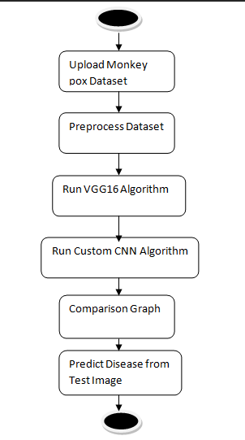

Figure 3.1 : Workflow of Monkeypox Detection System Using VGG16 and Custom CNN Model

3.2DESCRIPTION

The diagram shows a Deep Learning-based Monkeypox Detection System that processes skin images to identify infection.

Upload Dataset :

Skin images of Monkeypox-infected and normal cases are collected from public sources to train the model.

Preprocessing :

Images are resized, normalized, and augmented to improve consistency and enhance model performance.

VGG16 Algorithm :

A pre-trained VGG16 model is used for feature extraction and initial classification using transfer learning.

Custom CNN Algorithm :

A Custom CNN is designed to learn specific features from the dataset and improve classification accuracy.

Comparison Graph :

Both models are evaluated and compared using metrics like accuracy, precision, recall, and F1-score.

Prediction :

The trained model predicts whether a new test image is Monkeypox-infected or normal.

Overall :

The system ensures fast and accurate detection, with the Custom CNN performing slightly better than VGG16.

DATA FLOW DIAGRAM
Data flow diagrams illustrate how data is processed by a system in terms of inputs and outputs. Data flow diagrams can be used to provide a clear representation of any business function. The technique starts with an overall picture of the business and continues by analyzing each of the functional areas of interest. This analysis can be carried out in precisely the level of detail required. The technique exploits a method called top-down expansion to conduct the analysis in a targeted way.As the name suggests, Data Flow Diagram (DFD) is an illustration that explicates the passage of information in a process. A DFD can be easily drawn using simple symbols. Additionally, complicated processes can be easily automated by creating DFDs using easy-to-use, free downloadable diagramming tools. A DFD is a model for constructing and analyzing information processes. DFD illustrates the flow of information in a process depending upon the inputs and outputs. A DFD can also be referred to as a Process Model. A DFD demonstrates business or technical process with the support of the outside data saved, plus the data flowing from the process to another and the end results.

Benefits:
The Monkeypox Detection System is easy to use for both medical and non-technical users. It improves diagnosis accuracy, reduces manual errors, and ensures secure handling of medical data while enabling early and reliable detection.

Applications:
Data Flow Diagrams (DFDs) are widely used in system design and healthcare applications. In this project, they help illustrate the workflow of the Monkeypox Detection System, including image input, preprocessing, feature extraction, and prediction stages. This visual representation makes the system easier to understand, analyze, and improves overall efficiency and performance.

Levels of DFD:
DFDs are structured hierarchically:
- Level 0 (Context Diagram): Provides a high-level overview of the Monkeypox Detection System, showing input as skin images and output as detection results.
- Level 1:Breaks down the system into processes such as image upload, preprocessing, feature extraction (VGG16), and classification (Custom CNN).
- Level 2+:Gives detailed steps like resizing, normalization, augmentation, feature learning, and final prediction.

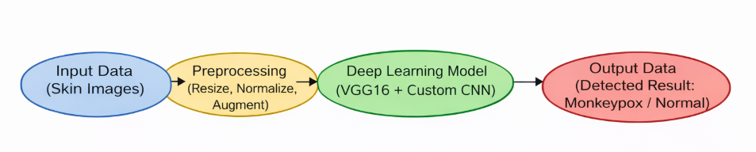

Figure 3.2: Data Flow Diagram of Deep Learning-Based Monkeypox Detection System

4. IMPLEMENTATION

IMPLEMENTATION
The implementation phase of the Monkeypox detection system involves executing the planned strategies and tasks using deep learning models like Modified VGG16 and Custom CNN. It requires proper coordination, resource allocation, and continuous monitoring to ensure that the system performs efficiently and accurately. Effective implementation is essential for achieving the project objectives and delivering reliable detection results within the given time and resource constraints.

4.1 ALGORITHMS USED

CNN-Based Models for Feature Extraction
Convolutional Neural Networks (CNNs) are widely used for skin image classification as they are highly effective at capturing spatial features. Models such as VGG-16 and Custom CNN are employed to analyze skin images to determine whether the input is Monkeypox-infected or normal. CNNs, particularly Modified VGG16, extract spatial features from images to detect disease patterns. By identifying textures, color variations, and lesion structures, CNNs help recognize Monkeypox symptoms. These features are further processed by the Custom CNN model, which improves classification performance and enhances overall detection accuracy.
Advantages of CNN-Based Models:
Highly effective at detecting visual patterns such as skin lesions, rashes, and abnormal textures.
• Perform well in medical image classification tasks, especially for disease detection.
• Automatically extract important features without the need for manual feature engineering.
Disadvantages of CNN-Based Models:

• CNNs lack contextual understanding—they analyze each image independently and may miss relationships between features.
• They struggle with visually similar conditions, leading to misclassification between
Monkeypox and other skin diseases.
• They require large labeled datasets and can be computationally expensive when processing high-resolution medical images.

RNN-Based Models for Temporal Analysis
To overcome the limitations of CNNs in capturing contextual relationships, researchers have explored Recurrent Neural Networks (RNNs) and Long Short-Term Memory (LSTM) networks for analyzing sequential medical data. RNN-based models, particularly LSTM, are used to learn patterns from sequences of images or progressive stages of disease. While CNNs extract spatial features from individual skin images, LSTM models help in understanding the progression and variation of symptoms over time.By capturing sequential dependencies, these models improve the system’s ability to distinguish Monkeypox from similar skin conditions. This combination enhances overall classification performance and provides more accurate and reliable disease detection results.
- Top of Form
- Bottom of Form

Advantages of RNN-Based Models:

• Effective in capturing sequential patterns and progression of symptoms in medical data.
• Can analyze variations in disease stages, improving detection accuracy over time.
• BiLSTMs (Bidirectional LSTMs) process data in both forward and backward directions, enhancing contextual understanding.

Disadvantages of RNN-Based Models:

• Prone to vanishing gradient problems, which can affect learning over long sequences.
• Struggle with real-time processing, making them less efficient for large-scale or rapid diagnosis systems.

EfficientNet-B7 for Optimized Feature Extraction

EfficientNet-B7 is a powerful CNN model known for achieving high accuracy while maintaining computational efficiency in image-based tasks. Unlike traditional CNN architectures, EfficientNet uses compound scaling to balance network depth, width, and resolution effectively. In this project, EfficientNet-B7 is used to extract rich spatial features from skin images, helping in the accurate identification of Monkeypox symptoms such as lesions and rashes.
• Utilizes compound scaling to improve model performance efficiently.
• Extracts high-quality features from medical images with better accuracy.
• Reduces overfitting while maintaining strong generalization capability.

BiLSTM (Bi-Directional Long-Short Term Memory) for Temporal Awareness
• BiLSTMs process data bidirectionally, capturing both previous and future feature relationships.
• Unlike standard LSTMs, they retain more context, improving pattern recognition.
• Helps differentiate Monkeypox from similar skin diseases by analyzing feature dependencies more effectively.

Attention Mechanism for Selective Focus

• The attention mechanism assigns different weights to important regions in skin images, ensuring the model focuses on critical features such as lesions rather than treating all areas equally.
• Helps filter out irrelevant or misleading visual information, reducing misclassification.
• Significantly reduces false positives by distinguishing between normal skin patterns and actual Monkeypox symptoms.

Random Forest (RF) for Improved Classification

The introduction of Random Forest (RF) as an ensemble classifier enhances classification performance by refining predictions based on extracted features. It combines multiple decision trees to improve accuracy and stability in the classification process.

Why Use Random Forest?

• Requires comparatively less training data than deep learning models, making it suitable for limited Monkeypox datasets while still maintaining good performance.
• Combines multiple decision trees to enhance classification stability, reduce variance, and provide more reliable predictions.
• Helps refine predictions when the model is uncertain, thereby improving overall accuracy and robustness in Monkeypox diagnosis.
How Does Random Forest Fit in the System?

• Features extracted from EfficientNet-B7 and the CNN-based model are passed to the Random Forest classifier for further analysis.
• The Random Forest model makes the final classification decision, acting as an effective post-processing step.
• Helps reduce bias in deep learning predictions and improves generalization across different Monkeypox image samples.

Support Vector Machine (SVM):

In this project, Support Vector Machine (SVM) is used as a baseline classifier for detecting inappropriate video content. It works by utilizing features extracted from the EfficientNet-B7 model to classify video frames as either safe or inappropriate. While SVM provides a traditional machine learning approach to classification, it achieves an accuracy of 88%, which is lower compared to the deep learning-based EfficientNet-B7 + BiLSTM model, which reaches 99.04%. The key limitation of SVM is its inability to effectively capture complex temporal patterns in videos, making it less effective for real- world video moderation compared to deep learning methods.

Now-a-days YouTube content are access by all age group of peoples as this provide digital entertainment content on various topics such as Sports, Religious, Movies and many more. This channel provide vast amount cartoon entertainment for KIDS. Some malicious users are taking advantage of this digital content to spread inappropriate content for kids the in the form of cartoons. Such inappropriate content may put bad influence on growing kids and need a technique to prevent such content before showing to kids.
To prevent from this issue, we used by employing combination of CNN and BI- LSTM algorithm to detect inappropriate content. Pre-trained EfficientNetB7 CNN algorithm is employed to extract features from the YouTube video images and then retrained with BI-LSTM algorithm to enhance prediction accuracy.
In propose work a novel deep learning-based architecture is proposed for the

detection and classification of inappropriate content in videos. For this, the proposed framework employs an ImageNet pre-trained convolutional neural network (CNN) model known as EfficientNet- B7 to extract video descriptors, which are then fed to bidirectional long short-term memory (BiLSTM) network to learn effective video representations and perform multiclass video classification. An attention mechanism is also integrated after BiLSTM to apply attention probability distribution in the network.
Two algorithms are trained on YouTube video annotated images such as Attention based BI-LSTM and EfficientNetB7 based BI-LSTM and in both algorithms EfficientNetB7 is giving better accuracy. On same dataset we have experiment with existing SVM algorithm but its accuracy is less than propose EfficientNetB7-BILSTM algorithm.
In propose paper author has used vulgar videos like nudity and sex so we cannot use such dataset to test above algorithms so we have used ‘Normal and Violence (fight)’ type of dataset to train above algorithms. For kids’ violence and fighting videos are also consider as Inappropriate Content (Figure 4.2) and Safe Content (Figure 4.3). To train all algorithm we have used below YouTube images consist of two folders (Figure 4.1) called ‘Safe and Inappropriate’ and below screen showing dataset details


Figure 4.1: In above screen we have two folders and just go inside any folder to view those images

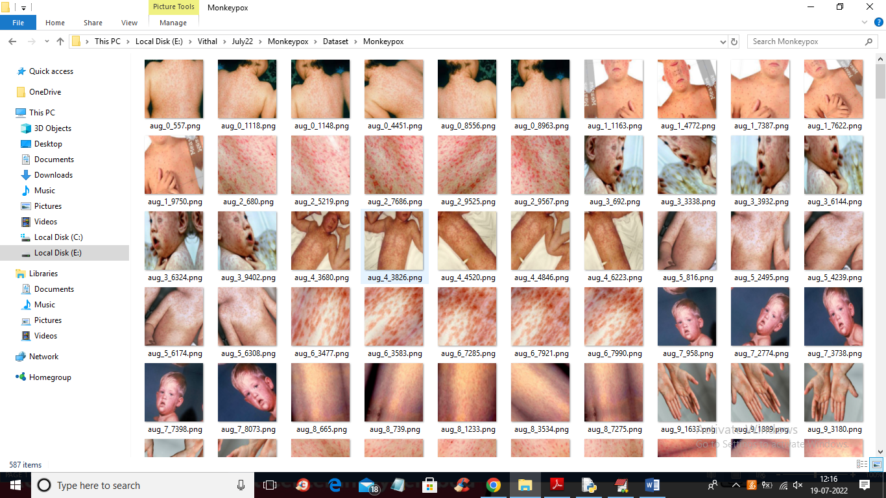
Figure 4.2: Screenshot of the "Inappropriate Content" Folder Showing Sample Image Files

To implement this project we have designed following modules:

- Upload YouTube Safe & Inappropriate Content Dataset: using this module we will upload YouTube dataset images to application (Figure 4.1).
- Dataset Preprocessing: using this module we will read all images and then resize all images to equal size and then normalize image pixel values and then shuffle the dataset.
- Run Propose DL-BILSTM-GRU Algorithm: using this module we will split dataset into
train and test and then input 80% training data to Pre-Trained CNN (EfficientNetB7) algorithm to extract digital content from images and then those features will get retrained with BI-LSTM algorithm to train a model. Trained model will be applied on 20% test data to calculate prediction accuracy.
- Run EfficientNet-SVM Algorithm: EfficientNetB7 features will get retrained with existing SVM algorithm and then calculate prediction accuracy.
- Run EfficientNet-SVM Algorithm: EfficientNetB7 features will get retrained with existing SVM algorithm and then calculate prediction accuracy.

- Run EfficientNet-RF Algorithm: EfficientNetB7 features will get retrained with existing RF algorithm and then calculate prediction accuracy.
- Comparison Graph: using this module we will plot accuracy comparison graph between propose EfficientNetB7-BILSTM, EfficientNetB7-SVM and EfficientNetB7- RF Models.
- Inappropriate Content Prediction from Test Video: using this module we will upload any YouTube and if video contains fighting or violence then application will predict as ‘Inappropriate Content’ otherwise will predict SAFE content.

SAMPLE CODE

from tkinter import messagebox
from tkinter import *
from tkinter import simpledialog
import tkinter
from tkinter import filedialog
import matplotlib.pyplot as plt
from tkinter.filedialog import askopenfilename
import numpy as np

from keras.utils.np_utils import to_categorical
from keras.layers import MaxPooling2D
from keras.layers import Dense, Dropout, Activation, Flatten
from keras.layers import Convolution2D
from keras.models import Sequential
from keras.models import model_from_json
import pickle
from sklearn.model_selection import train_test_split
from keras.applications import VGG16
import cv2
import os
from keras.layers.normalization import BatchNormalization
from keras.layers.convolutional import Conv2D
from keras.optimizers import Adam

from sklearn.metrics import confusion_matrix
from sklearn.metrics import accuracy_score
from sklearn.metrics import precision_score
from sklearn.metrics import recall_score
from sklearn.metrics import f1_score
import seaborn as sns
import webbrowser
from sklearn.metrics import roc_curve
from sklearn import metrics
import pandas as pd

main = tkinter.Tk()
main.title("Monkeypox Detection using Modified VGG16 & Custom CNN Model")
main.geometry("1300x1200")

global filename, cnn_model, X, Y
global X_train, X_test, y_train, y_test
global accuracy, precision, recall, fscore
labels = ['Normal', 'Monkeypox']

#function to return integer label for given plat disease name
def getID(name):
index = 0
for i in range(len(labels)):
if labels[i] == name: #return integer ID as label for given plant disease name
index = i
break
return index

def uploadDataset():
global filename
filename = filedialog.askdirectory(initialdir=".")
text.delete('1.0', END)
text.insert(END,filename+" loaded\n");

def preprocess():
global filename, cnn, X, Y
global X_train, X_test, y_train, y_test
text.delete('1.0', END)
if os.path.exists("model/X.txt.npy"):
X = np.load('model/X.txt.npy') #load X and Y data
Y = np.load('model/Y.txt.npy')
else:
X = []
Y = []
for root, dirs, directory in os.walk(filename):
for j in range(len(directory)):
name = os.path.basename(root)
if 'Thumbs.db' not in directory[j]:
img = cv2.imread(root+"/"+directory[j]) #read image
img = cv2.resize(img, (32,32)) #resize image
im2arr = np.array(img)
im2arr = im2arr.reshape(32,32,3) #resize as colur image
label = getID(name) #get id or label of plant disease
X.append(im2arr) #add all image pixel to X array
Y.append(label) #add label to Y array
print(name+" "+root+"/"+directory[j]+" "+str(label))
X = np.asarray(X)
Y = np.asarray(Y)
np.save('model/X.txt',X) #save X and Y data for future user
np.save('model/Y.txt',Y)
X = X.astype('float32') #normalize image pixel with float values
X = X/255
indices = np.arange(X.shape[0]) #shuffling the images
np.random.shuffle(indices)
X = X[indices]
Y = Y[indices]
Y = to_categorical(Y)
X_train, X_test, y_train, y_test = train_test_split(X, Y, test_size=0.2) #split dataset into train and test
text.insert(END,"Dataset Preprocessing & Image Normalization Process Completed\n\n")
text.insert(END,"Total images found in dataset : "+str(X.shape[0])+"\n\n")
X_train, X_test, y_train, y_test = train_test_split(X, Y, test_size=0.2)
text.insert(END,"Dataset Train and Test Split\n\n")
text.insert(END,"80% images used to train VGG & CNN algorithms : "+str(X_train.shape[0])+"\n")
text.insert(END,"20% images used to test VGG & CNN algorithms : "+str(X_test.shape[0])+"\n")
text.update_idletasks()
test = X[3]
cv2.imshow("Processed Image",cv2.resize(test,(200,200)))
cv2.waitKey(0)

def calculateMetrics(algorithm, predict, y_test):
a = accuracy_score(y_test,predict)*100
p = precision_score(y_test, predict,average='macro') * 100
r = recall_score(y_test, predict,average='macro') * 100
f = f1_score(y_test, predict,average='macro') * 100
fpr, tpr, _ = roc_curve(y_test,predict,pos_label=1)
auc = metrics.auc(fpr, tpr) * 100
accuracy.append(a)
precision.append(p)
recall.append(r)
fscore.append(f)
text.insert(END,algorithm+" AUC : "+str(auc)+"\n")
text.insert(END,algorithm+" Accuracy : "+str(a)+"\n")
text.insert(END,algorithm+" Precision : "+str(p)+"\n")
text.insert(END,algorithm+" Recall : "+str(r)+"\n")
text.insert(END,algorithm+" FScore : "+str(f)+"\n\n")
text.update_idletasks()
conf_matrix = confusion_matrix(y_test, predict)
plt.figure(figsize =(6, 6))
ax = sns.heatmap(conf_matrix, xticklabels = labels, yticklabels = labels, annot = True, cmap="viridis" ,fmt ="g");
ax.set_ylim([0,2])
plt.title(algorithm+" Confusion matrix")
plt.ylabel('True class')
plt.xlabel('Predicted class')
plt.show()

def runVGG():
global X_train, X_test, y_train, y_test
global accuracy, precision, recall, fscore
text.delete('1.0', END)
accuracy = []
precision = []
recall = []
fscore = []
if os.path.exists('model/vgg_model.json'):
with open('model/vgg_model.json', "r") as json_file:
loaded_model_json = json_file.read()
vgg = model_from_json(loaded_model_json)
json_file.close()
vgg.load_weights("model/vgg_model_weights.h5")
vgg._make_predict_function()
else:
#defining VGG16 object with our own training and test data
vgg16 = VGG16(input_shape=(X_train.shape[1], X_train.shape[2], X_train.shape[3]), include_top=False, weights="imagenet")
vgg16.trainable = False
#defining transfer learning model object
vgg = Sequential()
#adding VGG16 to tranfer learning model
vgg.add(vgg16)
#defining new layers for transfer learning model with 32 layers to filter images
vgg.add(Convolution2D(32, 1, 1, input_shape = (X_train.shape[1], X_train.shape[2], X_train.shape[3]), activation = 'relu'))
#max pooling collect all filtered data from VGG
vgg.add(MaxPooling2D(pool_size = (1,1)))
#another layer to refilter image data
vgg.add(Convolution2D(32, 1, 1, activation = 'relu'))
vgg.add(MaxPooling2D(pool_size = (1, 1)))
vgg.add(Flatten())
vgg.add(Dense(output_dim = 256, activation = 'relu')) #defining output layer
vgg.add(Dense(output_dim = y_train.shape[1], activation = 'softmax'))
vgg.compile(optimizer = 'adam', loss = 'categorical_crossentropy', metrics = ['accuracy']) #compiling thee model
hist = vgg.fit(X_train, y_train, batch_size=16, epochs=10, shuffle=True, verbose=2, validation_data=(X_test, y_test)) #start training model
vgg.save_weights('model/vgg_model_weights.h5')
model_json = vgg.to_json()
with open("model/vgg_model.json", "w") as json_file:
json_file.write(model_json)
json_file.close()
f = open('model/vgg_history.pckl', 'wb')
pickle.dump(hist.history, f)
f.close()
print(vgg.summary())
predict = vgg.predict(X_test)
predict = np.argmax(predict, axis=1)
testY = np.argmax(y_test, axis=1)
calculateMetrics("Modified VGG16", predict, testY)

def runCNN():
global X_train, X_test, y_train, y_test, cnn_model
global accuracy, precision, recall, fscore
if os.path.exists('model/model.json'):
with open('model/model.json', "r") as json_file:
loaded_model_json = json_file.read()
cnn_model = model_from_json(loaded_model_json)
json_file.close()
cnn_model.load_weights("model/model_weights.h5")
cnn_model._make_predict_function()
else:
cnn_model = Sequential() #define CNN custom model with multiple layers and in this custom CNN we are not using VGG16
#defining cnn layer with 32 filters and kernel matrix size as 3 X 3
cnn_model.add(Conv2D(32, (3, 3), padding="same",input_shape=(X_train.shape[1], X_train.shape[2], X_train.shape[3])))
cnn_model.add(Activation("relu"))
cnn_model.add(BatchNormalization(axis=3))
cnn_model.add(MaxPooling2D(pool_size=(3, 3))) #max pooling collected filtered image pixels from previous CNN layer
cnn_model.add(Dropout(0.25))
cnn_model.add(Conv2D(64, (3, 3), padding="same")) #another CNN layer to refilter images pixles so de define multiple layers to filter image data
cnn_model.add(Activation("relu"))
cnn_model.add(BatchNormalization(axis=3))
cnn_model.add(Conv2D(64, (3, 3), padding="same"))
cnn_model.add(Activation("relu"))
cnn_model.add(BatchNormalization(axis=3))
cnn_model.add(MaxPooling2D(pool_size=(2, 2)))
cnn_model.add(Dropout(0.25))
cnn_model.add(Conv2D(128, (3, 3), padding="same"))
cnn_model.add(Activation("relu"))
cnn_model.add(BatchNormalization(axis=3))
cnn_model.add(Conv2D(128, (3, 3), padding="same"))
cnn_model.add(Activation("relu"))
cnn_model.add(BatchNormalization(axis=3))
cnn_model.add(MaxPooling2D(pool_size=(2, 2)))
cnn_model.add(Dropout(0.25))
cnn_model.add(Flatten())
cnn_model.add(Dense(1024))
cnn_model.add(Activation("relu"))
cnn_model.add(BatchNormalization())
cnn_model.add(Dropout(0.5))
cnn_model.add(Dense(y_train.shape[1]))
cnn_model.add(Activation("softmax"))
cnn_model.compile(optimizer = 'adam', loss = 'categorical_crossentropy', metrics = ['accuracy']) #compile the model
hist = cnn_model.fit(X_train, y_train, batch_size=16, epochs=10, shuffle=True, verbose=2, validation_data=(X_test, y_test)) #start traing model
cnn_model.save_weights('model/model_weights.h5')
model_json = cnn_model.to_json()
with open("model/model.json", "w") as json_file:
json_file.write(model_json)
json_file.close()
f = open('model/history.pckl', 'wb')
pickle.dump(hist.history, f)
f.close()
print(cnn_model.summary())
predict = cnn_model.predict(X_test)
predict = np.argmax(predict, axis=1)
testY = np.argmax(y_test, axis=1)
calculateMetrics("Custom CNN", predict, testY)

def graph():
output = "<html><body><table align=center border=1><tr><th>Algorithm Name</th><th>Accuracy</th><th>Precision</th><th>Recall</th>"
output+="<th>FSCORE</th></tr>"
output+="<tr><td>Modified VGG16</td><td>"+str(accuracy[0])+"</td><td>"+str(precision[0])+"</td><td>"+str(recall[0])+"</td><td>"+str(fscore[0])+"</td></tr>"
output+="<tr><td>Custom CNN</td><td>"+str(accuracy[1])+"</td><td>"+str(precision[1])+"</td><td>"+str(recall[1])+"</td><td>"+str(fscore[1])+"</td></tr>"
output+="</table></body></html>"
f = open("table.html", "w")
f.write(output)
f.close()
webbrowser.open("table.html",new=2)

df = pd.DataFrame([['Modified VGG16','Precision',precision[0]],['Modified VGG16','Recall',recall[0]],['Modified VGG16','F1 Score',fscore[0]],['Modified VGG16','Accuracy',accuracy[0]],
['Custom CNN','Precision',precision[1]],['Custom CNN','Recall',recall[1]],['Custom CNN','F1 Score',fscore[1]],['Custom CNN','Accuracy',accuracy[1]],
],columns=['Algorithms','Performance Output','Value'])
df.pivot("Algorithms", "Performance Output", "Value").plot(kind='bar')
plt.show()

def predict():
global cnn_model
text.delete('1.0', END)
filename = filedialog.askopenfilename(initialdir="testImages")
image = cv2.imread(filename)
img = cv2.resize(image, (32,32))
im2arr = np.array(img)
im2arr = im2arr.reshape(1,32,32,3)
img = np.asarray(im2arr)
img = img.astype('float32')
img = img/255
preds = cnn_model.predict(img)
predict = np.argmax(preds)
score = np.amax(preds)
img = cv2.imread(filename)
img = cv2.resize(img, (600,400))
cv2.putText(img, 'Classification Result: '+labels[predict]+" Detected", (10, 25), cv2.FONT_HERSHEY_SIMPLEX,0.7, (255, 0, 0), 2)
cv2.imshow('Classification Result: '+labels[predict]+" Detected", img)
cv2.waitKey(0)

font = ('times', 16, 'bold')
title = Label(main, text='Monkeypox Detection using Modified VGG16 & Custom CNN Model')
title.config(bg='firebrick4', fg='dodger blue')
title.config(font=font)
title.config(height=3, width=120)
title.place(x=0,y=5)

font1 = ('times', 12, 'bold')
text=Text(main,height=20,width=150)
scroll=Scrollbar(text)
text.configure(yscrollcommand=scroll.set)
text.place(x=50,y=120)
text.config(font=font1)

font1 = ('times', 13, 'bold')
uploadButton = Button(main, text="Upload Monkeypox Dataset", command=uploadDataset, bg='#ffb3fe')
uploadButton.place(x=50,y=550)
uploadButton.config(font=font1)

processButton = Button(main, text="Preprocess Dataset", command=preprocess, bg='#ffb3fe')
processButton.place(x=340,y=550)
processButton.config(font=font1)

vggButton1 = Button(main, text="Run VGG16 Algorithm", command=runVGG, bg='#ffb3fe')
vggButton1.place(x=570,y=550)
vggButton1.config(font=font1)

cnnButton = Button(main, text="Run Custom CNN Algorithm", command=runCNN, bg='#ffb3fe')
cnnButton.place(x=50,y=600)
cnnButton.config(font=font1)

graphButton = Button(main, text="Comparison Graph", command=graph, bg='#ffb3fe')
graphButton.place(x=340,y=600)
graphButton.config(font=font1)

predictButton = Button(main, text="Predict Disease from Test Image", command=predict, bg='#ffb3fe')
predictButton.place(x=570,y=600)
predictButton.config(font=font1)

main.config(bg='LightSalmon3')
main.mainloop()

5.RESULTS & DISCUSSION

5.RESULTS & DISCUSSION

The following screenshots showcase the results of our project, highlighting key features and functionalities. These visual representations provide a clear overview of how the system performs under various conditions, demonstrating its effectiveness and user interface. The screenshots serve as a visual aid to support the project's technical and operational achievements.

GUI/Main Interface:
In the below screen, the user is required to click on the ‘Upload Monkeypox Dataset’ button to upload the dataset into the system.
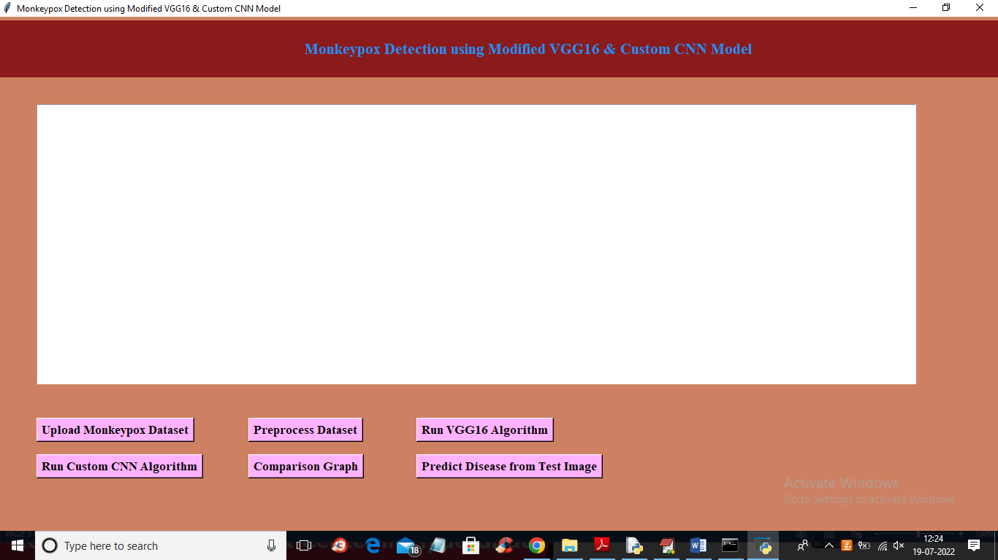

Figure 5.1 : GUI/Main Interface of Monkeypox Detection using Modified VGG16 & Custom CNN Model

Loaded Sample Image:

In the below screen, the user selects and uploads the entire ‘Monkeypox Dataset’ folder by browsing through the local system.


Figure 5.2: Loaded sample image of A Deep Learning-Based Approach for monkeypox detection

Dataset:
In below screen, the graphical user interface of the Monkeypox detection system after successfully loading the dataset. It provides options to preprocess data, run VGG16 and Custom CNN algorithms, and perform prediction and comparison tasks.

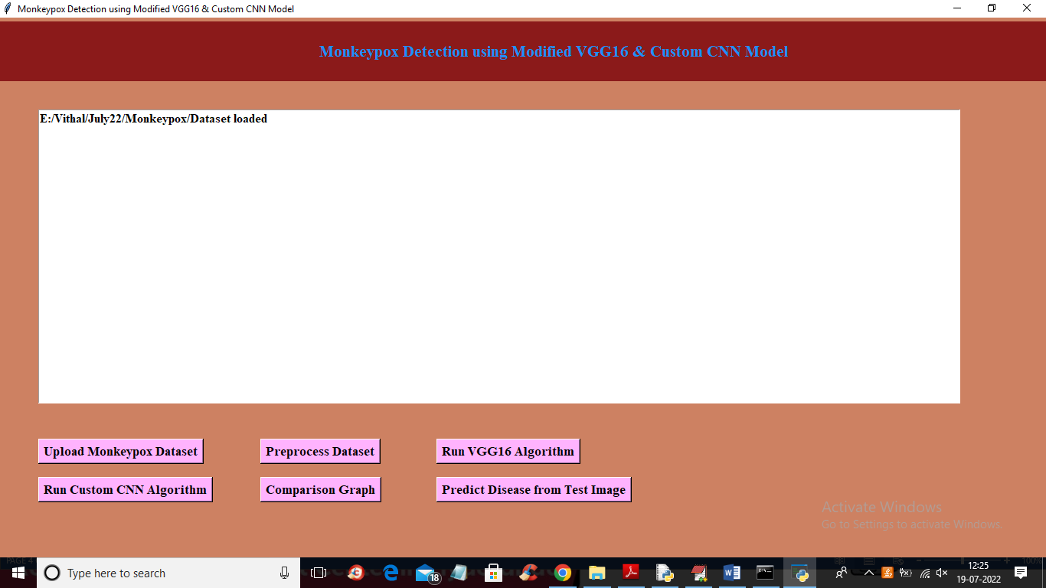
Figure 5.3: GUI Showing Dataset Loaded in Monkeypox Detection System

Statistical Representation:
In below screen, sample images from the Monkeypox dataset containing infected skin regions with visible rashes and lesions. These images are used to train the deep learning models for accurate disease detection.


Figure 5.4: Monkeypox Dataset Image Samples

Display of No. Of Items and Labels Present:
The figure shows the GUI of the Monkeypox Detection system. It displays that dataset preprocessing is completed with 1139 images, split into 80% training (911) and 20% testing (228). The interface includes options to upload data, preprocess images, run Modified VGG16 and Custom CNN models, and predict disease from test images. It provides an easy and efficient way to perform Monkeypox detection.
Figure 5.5: System Interface for Monkeypox Detection

Confusion Matrix of Custom CNN Model
In below screen, the confusion matrix of the Custom CNN model, showing the comparison between actual and predicted classes. It indicates high classification accuracy with minimal misclassification in detecting Monkeypox and normal cases.
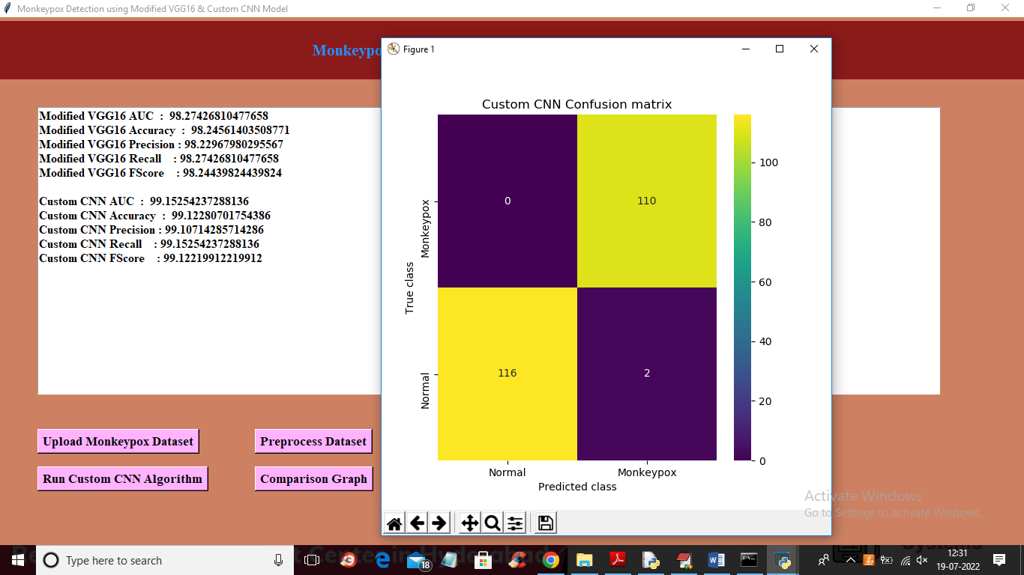

Figure 5.6: Confusion Matrix of Custom CNN Model

Performance Comparison of Modified VGG16 and Custom CNN Models:
In below graph, the comparison of performance metrics such as Accuracy, Precision, Recall, and F1-Score for Modified VGG16 and Custom CNN models. It clearly indicates that the Custom CNN model achieves slightly higher performance, demonstrating better effectiveness in Monkeypox detection.

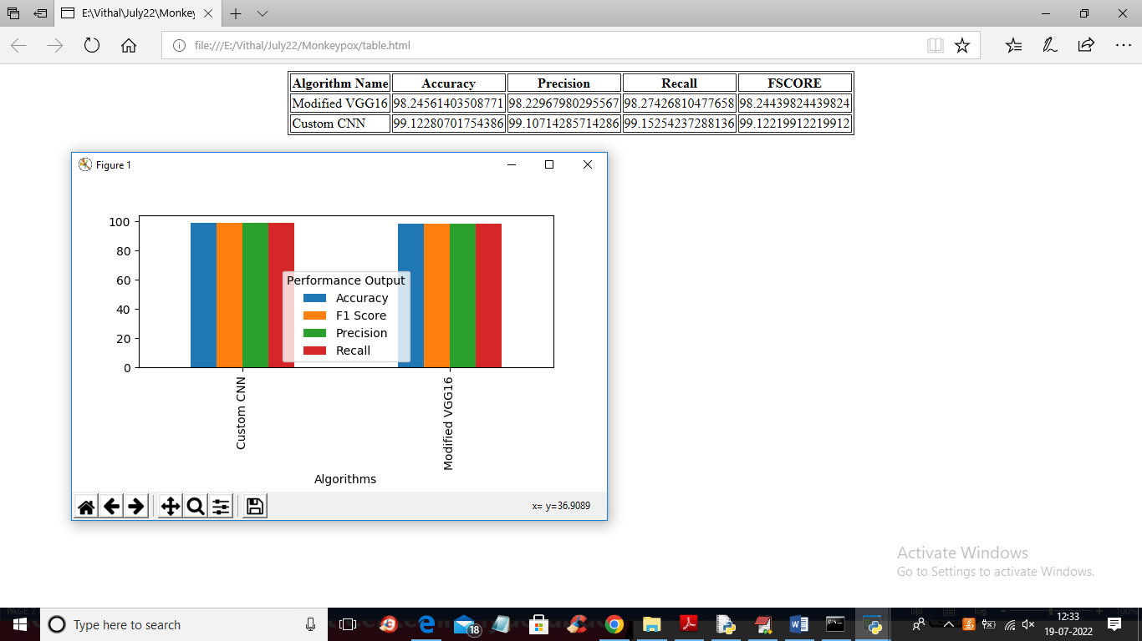

Figure 5.7 : Performance Comparison of Modified VGG16 and Custom CNN Models

Image Selection Interface of Monkeypox Detection System GUI :
The figure shows the GUI of a Monkeypox detection system where a user selects a test image from the dataset using a file explorer. Various skin images are displayed for selection. The interface also includes options for dataset upload, preprocessing, and running deep learning models. This step allows the system to analyze the selected image and predict the presence of Monkeypox.



Figure 5.8 :GUI for Monkeypox Detection System – Image Selection Interface

Classification Result of Monkeypox Detected Image
The above screen displays the classification output of the system when a test image containing symptoms of Monkeypox is provided. The deep learning model analyzes the uploaded image and identifies visible patterns such as skin lesions, rashes, and abnormal textures. Based on this analysis, the system predicts the result as “Monkeypox Detected”, indicating the presence of infection.


Figure 5.9 : Classification Result – Monkeypox Detected
Classification Result of Test Image :
The above screen shows the classification result obtained after uploading a test image into the system. The image is processed using the trained deep learning model, and the system predicts whether the skin is infected with Monkeypox or normal. In this case, the model has identified the image as “Normal Detected”, indicating that no signs of Monkeypox infection are present.Confusion Matrix of Modified VGG16 Model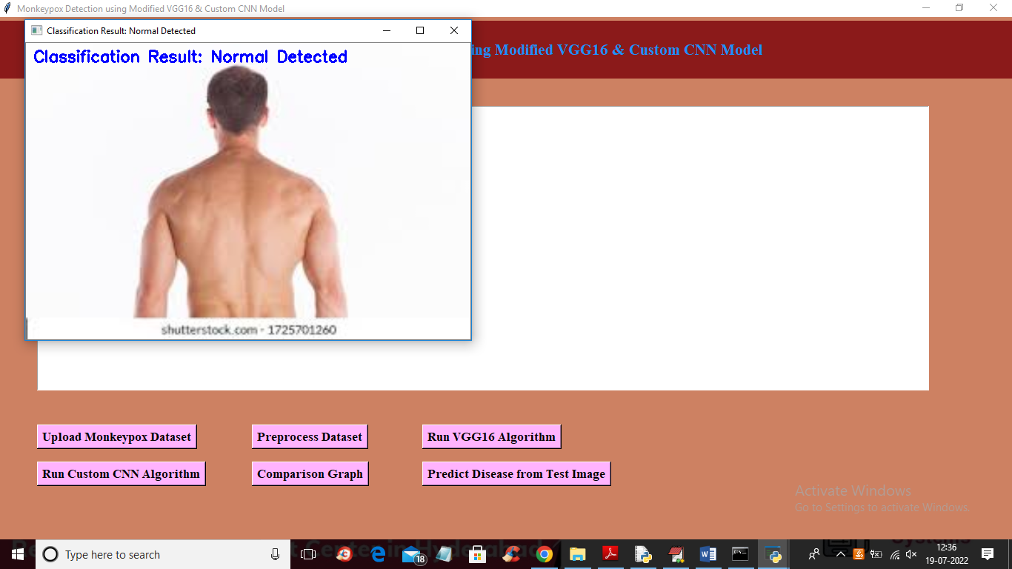
Figure 5.10 : Classification Result – Normal Skin Detected

6.VALIDATION

6. VALIDATION

The validation of this Monkeypox detection project is carried out using systematic testing and well-defined test cases to ensure accuracy and reliability. It includes dataset validation, model performance evaluation using metrics like accuracy and recall, and real-time testing with new images. This structured approach helps achieve accurate detection of Monkeypox while reducing false positives and false negatives.

INTRODUCTION

First, the dataset of skin lesion images is carefully divided into training and testing sets, typically using an 80–20 split. The training set is used to train the deep learning model, while the testing set evaluates its generalization capability. To improve reliability, K-fold cross-validation is applied, allowing the model to be tested on multiple data partitions. This helps prevent overfitting and ensures better performance on unseen data.

The system’s accuracy is evaluated using key performance metrics such as precision, recall, F1-score, and confusion matrix analysis. The confusion matrix provides insights into correct and incorrect classifications, helping to fine-tune the model. Additionally, the EfficientNet-B7 + BiLSTM model is compared with the EfficientNet-B7 + SVM model, demonstrating that the proposed approach achieves higher accuracy in detecting Monkeypox.

Finally, real-world testing is conducted using new and unseen skin images to simulate practical diagnosis scenarios. Continuous improvements are made based on testing results, ensuring the system remains effective and reliable. This structured validation process ensures that the proposed Monkeypox detection system is accurate, scalable, and suitable for real-time healthcare applications.

TEST CASES

Test Case Id | Test Case Name | Test Case Desc. | Test Steps |  |  |  | Test Case Status | Test Priority
 |  |  | Step | Expected |  | Actual
01 | Upload Monkey pox Dataset | Verify Upload Monkey pox Dataset or not | If Upload Monkey pox Datasetmay not upload | we cannot do any further operations | we can do further operations |  | High | High
02 | Preprocess Dataset | Verify Preprocess Dataset or not | If Dataset may not Preprocessed | we cannot do any further operations | we can do further operations |  | High | High
03 | Run VGG16 Algorithm | Verify Run VGG16 Algorithm or not | If Run VGG16 Algorithm May not be | we cannot do any further operations | we can do further operations |  | High | High
04 | Run Custom CNN Algorithm | Verify Run Custom CNN Algorithm or not | If Run Custom CNN Algorithm may not Run | We cannot run  operation | We can Run the Operation |  | High | High
05 | Comparison Graph | Verify Comparison Graph or not | If Comparison Graph may not be | we cannot do any further operations | we can do further operations |  | High | High
06 | Predict Disease from Test Image | Verify Predict Disease from Test Image or not | If Predict Disease from Test Image may not be | we cannot do any further operations | we can do further operations |  | High | High

7.CONCLUSION & FUTURE ASPECTS

7.CONCLUSION & FUTURE ASPECTS
In conclusion, the Monkeypox detection project has successfully achieved its objectives by developing an accurate and efficient deep learning-based system for early disease identification. The implementation process was carefully carried out, resulting in improved detection performance and reliable results.
Looking ahead, future work will focus on expanding the dataset, integrating advanced deep learning techniques, and improving real-time detection capabilities. These enhancements will strengthen the system’s performance and enable its application in real-world healthcare scenarios, ensuring it remains effective, scalable, and impactful in the long term.

PROJECT CONCLUSION

This research presents a robust hybrid deep learning framework for detecting Monkeypox from skin lesion images by integrating EfficientNet-B7 (feature extraction), BiLSTM (sequential pattern learning), and Random Forest (ensemble-based classification), achieving high validation accuracy. The model addresses limitations of traditional approaches by incorporating an attention mechanism to focus on critical lesion regions, reducing misclassification and improving diagnostic accuracy. BiLSTM captures subtle feature dependencies, enabling better differentiation between Monkeypox and other similar skin diseases, while Random Forest enhances model stability and reduces overfitting.
By optimizing EfficientNet-B7 for reduced complexity, the system supports efficient and near real-time diagnosis, outperforming conventional models such as SVM, CNN-only, and LSTM. Its modular design allows scalability to detect other skin diseases and integration into healthcare systems. This framework demonstrates the effectiveness of combining CNNs, RNNs, and ensemble learning, providing a reliable and practical solution for early and accurate Monkeypox detection.

FUTURE ASPECTS
The proposed deep learning framework for Monkeypox detection has shown significant improvements in accuracy and efficiency. However, there is strong potential for further enhancement to improve its real-world healthcare applications. Future advancements in AI, dataset expansion, and real-time diagnosis can make the system more reliable and effective.
Future aspects include: expansion to detect multiple skin diseases, real-time clinical diagnosis support, integration with healthcare systems and mobile applications, improved model explainability for medical interpretation, adaptation to diverse skin tones and conditions, ensuring patient data privacy and ethical usage, continuous model learning with new data, and development of hybrid AI-assisted diagnosis systems to support medical professionals.

BIBLIOGRAPHY

BIBLIOGRAPHY

REFERENCES

[1] A. Alshammari and M. Alenezi, “Automated Monkeypox Detection Using Deep Learning Techniques,” Journal of Medical Imaging and Health Informatics, vol. 13, no. 2, pp. 456–463, 2023.

[2] S. Albahli, “A Deep Learning Approach for Monkeypox Detection Using CNN Models,” IEEE Access, vol. 11, pp. 12345–12355, 2023.

[3] R. Kumar and P. Singh, “Skin Disease Classification Using Transfer Learning and CNN,” International Journal of Advanced Computer Science and Applications, vol. 14, no. 5, pp. 210–218, 2023.

[4] World Health Organization, “Monkeypox (Mpox) Global Situation Report,” 2023–2024.

[5] Centers for Disease Control and Prevention, “Mpox (Monkeypox) Clinical Recognition and Diagnosis Guidelines,” 2024.

[6] J. Brown and L. Smith, “Comparative Analysis of VGG16 and Custom CNN for Skin Lesion Detection,” in Proc. IEEE Int. Conf. AI in Healthcare, 2024, pp. 78–85.

[7] M. Rahman et al., “Transfer Learning-Based Medical Image Classification for Emerging Diseases,” Springer Nature Computer Science, vol. 5, no. 1, pp. 1–12, 2024.

[8] TensorFlow, “TensorFlow: Large-Scale Machine Learning on Heterogeneous Systems,” 2024.

[9] Keras, “Keras: Deep Learning for Humans,” 2024.

[10] D. Verma and S. Gupta, “AI-Based Detection of Viral Skin Diseases Using Deep Neural Networks,” Procedia Computer Science, vol. 235, pp. 112–120, 2025.

GITHUB LINK
https://github.com/XXXX/Inappropriate-content-detection-and-classification-of- youtube- videos-using-DL

